WEEK 2 PROJECT REPORT

Data Modeling, DAX & Sales Dashboard
Superstore Sales Business Intelligence Project — Power BI Desktop
Dataset: Superstore Sales Dataset (Preprocessed from Week 1)

Veeneshwari R
E25DA044
BSC Data Science and Artificial Intelligence

Table of Contents
1. Introduction
2. Objectives
3. Dataset & Problem Statement
4. Data Modeling — Star Schema
5. Building the DAX Measure Table
6. Dashboard Design & Visual Construction
7. Dashboard Walkthrough — Full Data View
8. Interactivity — Year & Category Filtering
9. Key Insights from the Dashboard
10. Challenges & Learnings
11. Conclusion

1. Introduction
This report documents the second stage of a two-week Power BI learning project built around the Superstore Sales dataset, a widely used retail transactions dataset covering customer orders, product categories, regional shipments, and profitability across multiple years. Week 1 focused on importing the raw dataset into Power BI Desktop, inspecting its structure through the Power Query Editor, cleaning categorical text fields, and enriching the table with temporal attributes derived from the Order Date column.
Week 2 builds directly on that cleaned data model. The objective shifts from data preparation to data modeling and analysis: establishing relationships between tables, writing reusable DAX (Data Analysis Expressions) measures, and assembling those measures into an interactive, decision-ready dashboard. The end deliverable is a single-page 'Superstore Sales Dashboard' that lets a business stakeholder monitor total sales, profit, order volume, and quantity, and drill into that performance by category, sub-category, region, segment, and year.
This document walks through the modeling decisions, the measures written, the visuals constructed, and the way the dashboard responds to filtering — supported by screenshots captured directly from the working Power BI report.

2. Objectives
The Week 2 module set out the following learning and delivery objectives:
- Establish table relationships and understand data model structures, specifically the Star Schema pattern used in analytical models.
- Write foundational DAX measures: Total Sales, Total Profit, Total Orders, Total Quantity, Average Sales, and Profit Margin %.
- Construct visual layouts using KPI Cards, Stacked Bar Charts, Line Charts, Donut Charts, and Decomposition Trees.
- Configure slicers, cross-filtering, interactive tooltips, and drill-down paths so the dashboard responds dynamically to user selections.

These objectives translated into four concrete tasks and deliverables:
- Build a dedicated DAX measure table (named _Measures) to keep all calculations organized and separate from raw data columns.
- Create a top-line executive summary bar using KPI cards for the headline numbers.
- Build category performance and regional profitability visual breakdowns.
- Deliver a complete, interactive Superstore Sales Dashboard on a single report page.

3. Dataset & Problem Statement
Dataset: Superstore Sales Dataset, preprocessed and cleaned during Week 1 (Power Query transformations applied: text standardization, custom date columns, data type coercion).
Problem Statement: Management at the retail organization wants a single, interactive view to monitor sales, profit, orders, and customer activity across regions. Rather than requesting static spreadsheet exports, they need a live dashboard that lets them slice performance by year, product category, segment, and region without waiting on a new report each time a question changes.
The Data pane confirms the shape of the model going into Week 2: a fact table carrying transactional grain (Row ID, Order ID, Product ID, Customer ID) alongside measure-ready numeric columns — Sales, Profit, Quantity, and Discount — plus descriptive attributes such as Category, Sub-Category, Segment, Region, State/Province, City, Ship Mode, Ship Date, and Order Date. A dedicated Date Hierarchy is exposed under Order Date, which is what powers the Year drill-down used throughout the dashboard.

4. Data Modeling — Star Schema
A Star Schema arranges data into a single central fact table (the transactional records — here, each order line with its Sales, Profit, Quantity, and Discount) surrounded by descriptive dimension context such as Category, Segment, Region, and the Order Date hierarchy. This structure was preferred over a single flat table because it keeps filtering, sorting, and aggregation fast and predictable as the report grows, and it lets one dimension — for example Order Date — filter multiple visuals consistently across the whole page.
Within Power BI, the Order Date field was expanded into a Date Hierarchy (Year → Quarter → Month → Day), inherited from the Week 1 Power Query transformations. This hierarchy is what allows the 'Year and Category' panel on the dashboard to behave as a nested, expandable filter tree rather than a flat list of dates.
Relationships between the fact table and its descriptive fields were validated in Power BI's Model view before any visuals were built, ensuring that filters set on one field (for example, selecting the year 2024) would correctly propagate to every card, chart, and table on the report canvas.
5. Building the DAX Measure Table
Following best practice, all calculations were written as explicit DAX measures and grouped into a dedicated measure table (_Measures) rather than left as implicit column aggregations. This keeps the Data pane organized, makes measures reusable across every visual, and avoids the row-level context pitfalls of calculated columns. The measures visible in the model are summarized below.

DAX Measure | Purpose
Total Sales | Sums the Sales column across the current filter context; the primary revenue KPI shown on the dashboard's headline card.
Total Profit | Sums the Profit column; paired with Total Sales to assess overall business health.
Total Orders | Counts distinct Order IDs, giving order volume independent of line-item quantity.
Total Quantity | Sums the Quantity column; tracks units sold rather than revenue.
Average Sales | Total Sales divided by order or transaction count; highlights typical basket value.
Profit Margin % | Total Profit divided by Total Sales, formatted as a percentage; the key efficiency KPI on the dashboard.

Representative DAX syntax used for the core measures:
Total Sales = SUM('Sample super data'[Sales])
Total Profit = SUM('Sample super data'[Profit])
Total Orders = DISTINCTCOUNT('Sample super data'[Order ID])
Total Quantity = SUM('Sample super data'[Quantity])
Average Sales = DIVIDE([Total Sales], [Total Orders])
Profit Margin % = DIVIDE([Total Profit], [Total Sales])

Writing Profit Margin % with DIVIDE() rather than a plain '/' operator matters in practice: DIVIDE() returns a blank instead of an error when Total Sales is zero for a given filter selection — for instance, a category with no orders in a chosen year — which keeps card visuals and charts from breaking when a user drills into an empty slice of the data.

6. Dashboard Design & Visual Construction
With the measure table in place, the report canvas was built out as a single page titled 'Superstore Sales Dashboard', arranged so the highest-priority numbers sit at the top-left, in line with natural left-to-right, top-to-bottom reading order.
- Executive summary bar: four KPI cards — Total Profit, Total Sales, Total Quantity (shown twice, mirrored for symmetry), and Profit Margin % — give an at-a-glance read of overall performance.
- Total Sales by Order Date: a line chart plotting sales across the order date timeline, used to spot trends, seasonality, and spikes.
- Total Sales by Category: a donut chart breaking total sales into Technology, Furniture, and Office Supplies, with percentage-of-total labels.
- Total Sales by Region: a horizontal bar chart comparing East, West, Central, and South regions.
- Total Profit by Sub-Category: a horizontal bar chart ranking sub-categories (Copiers, Phones, Accessories, Paper, Binders, Chairs, and more) by profit contribution, with a scrollable axis.
- Total Sales by Category (bar variant): a second, bar-chart view of category-level sales for direct magnitude comparison alongside the donut chart.
- Total Sales, Count of Segment and First Category: a gauge/radial visual summarizing sales against a target, alongside segment counts.
- Year and Category slicer panel: an expandable tree (2023–2026, each with Furniture, Office Supplies, and Technology nested beneath) that filters every visual on the page simultaneously.

Cross-filtering and interactive tooltips were enabled by default — clicking any bar, donut segment, or year node filters the rest of the page. The 'Keep all filters' option was switched on for drill-through so that context carries over if a user navigates to a detail page, and Cross-report drill-through was left off since this project uses a single dashboard page.

7. Dashboard Walkthrough — Full Data View
The screenshot below shows the finished dashboard with no year or category filters applied — every order in the Superstore dataset is included. At this unfiltered level, the business is shown generating 2.33M in Total Sales against 292.30K in Total Profit, a blended Profit Margin of 13%, on 39K units of Total Quantity sold.
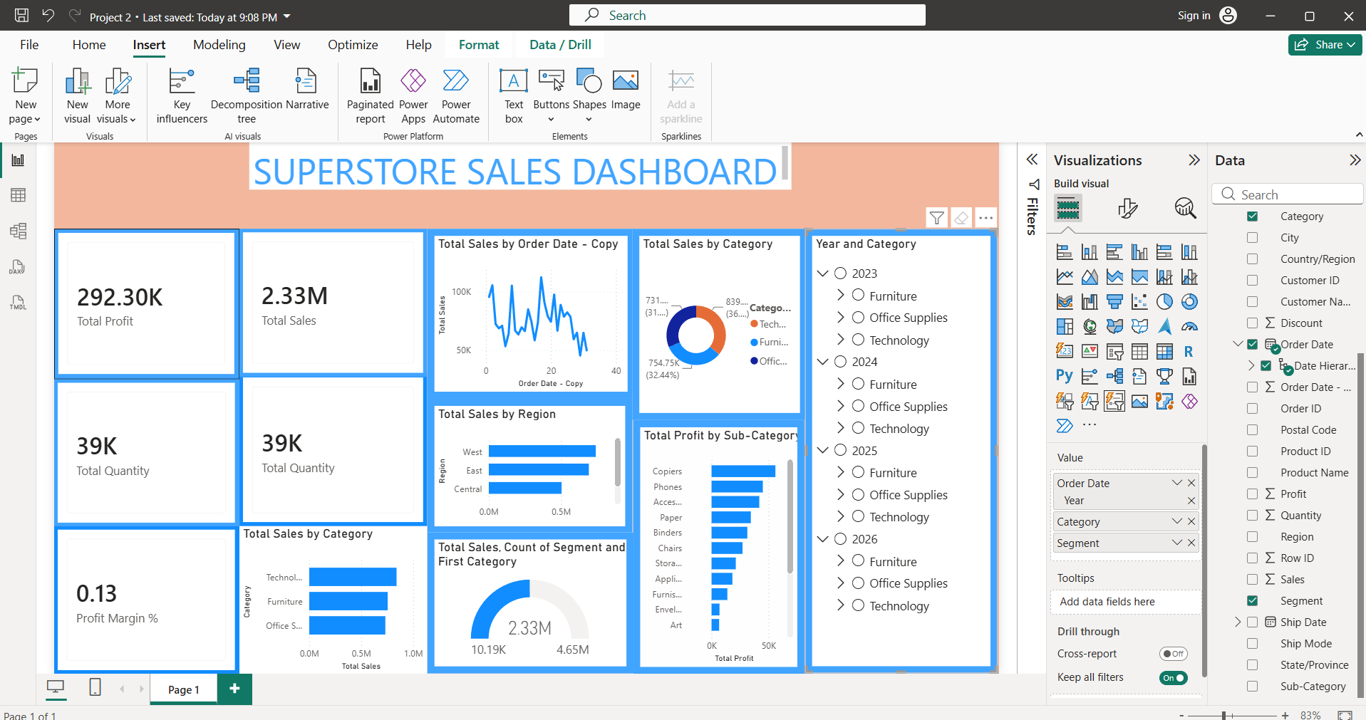
Figure 1 — Superstore Sales Dashboard, unfiltered (all years, all categories).
The Total Sales by Category donut shows Technology as the leading category at roughly 32–36% of sales, closely followed by Office Supplies and Furniture, with all three in a fairly balanced three-way split — a pattern that recurs in the Total Sales by Category bar chart directly below it. The Total Profit by Sub-Category chart singles out Copiers and Phones as the strongest profit contributors, while the Total Sales by Order Date line chart shows a noisy but broadly stable trend with periodic spikes, consistent with order-driven retail seasonality rather than a steady decline or growth trend.

8. Interactivity — Year & Category Filtering
To confirm the dashboard behaves as a genuinely interactive tool rather than a static image, the Year and Category slicer panel was exercised directly on the canvas. Selecting the year 2024 together with all three categories (Furniture, Office Supplies, Technology) instantly recalculates every card and chart on the page.
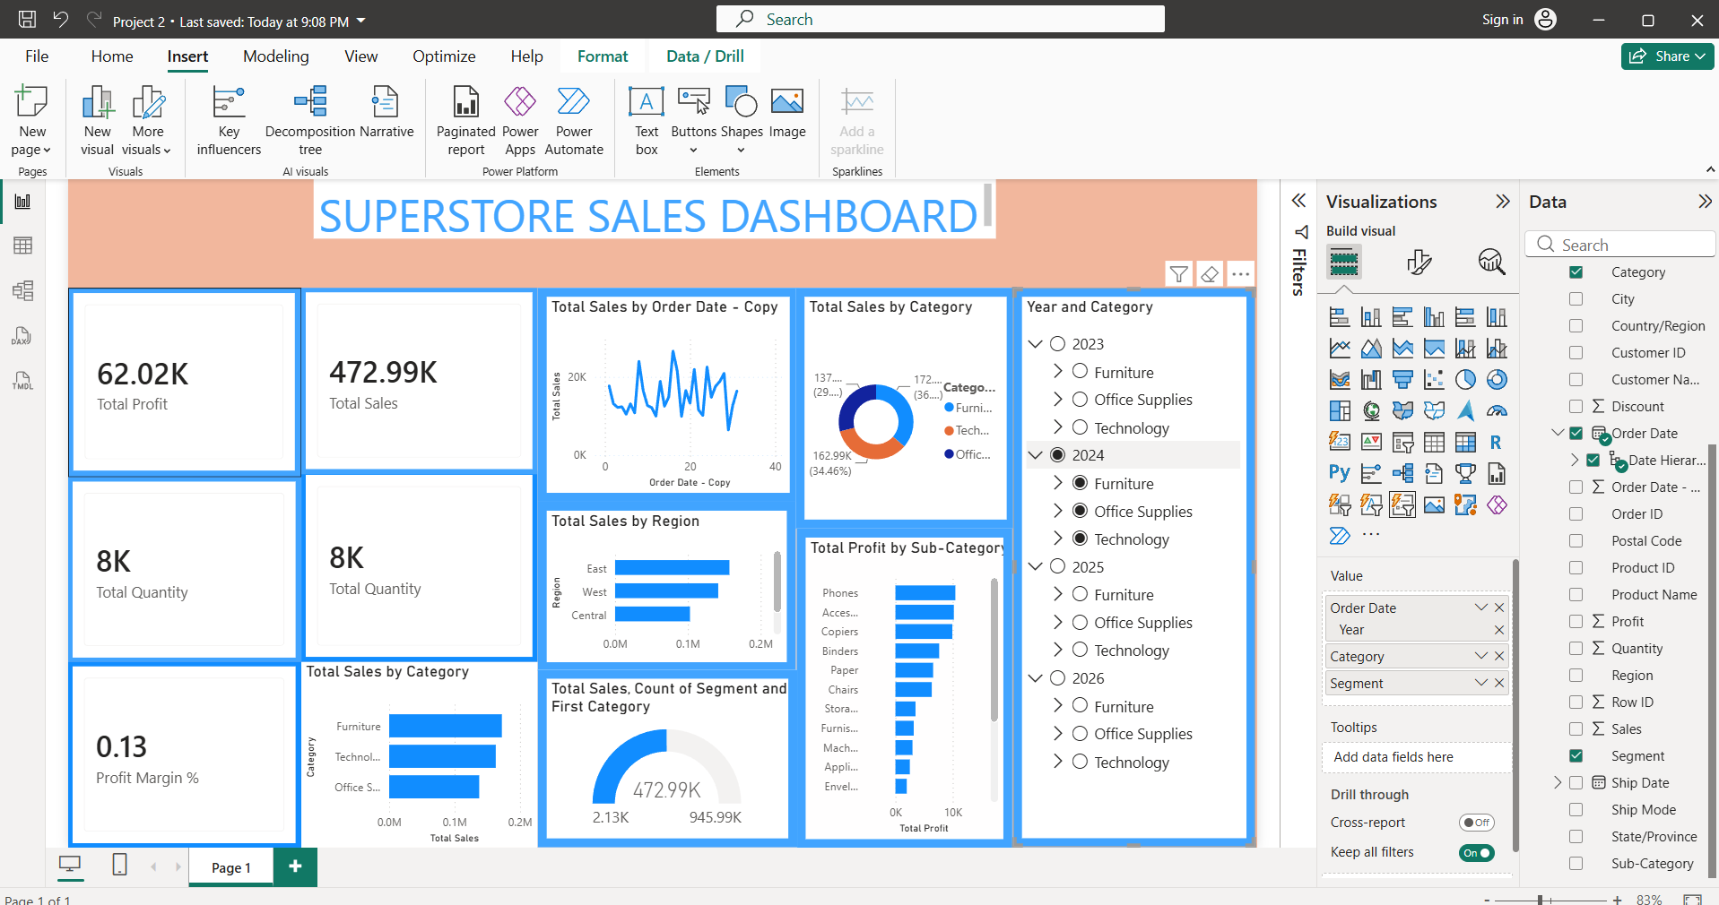
Figure 2 — Dashboard filtered to Year = 2024, all categories selected.
With the 2024 filter applied, Total Sales drops to 472.99K and Total Profit to 62.02K, with Profit Margin improving slightly to 13%. The regional bar chart re-ranks itself — East overtakes West as the top-selling region for that year — and the sub-category profit ranking reshuffles, with Phones moving ahead of Copiers. This confirms that the slicer, the DAX measures, and the underlying Star Schema relationships are all wired correctly: a single click on a year node propagates through every visual on the page without manual refresh.
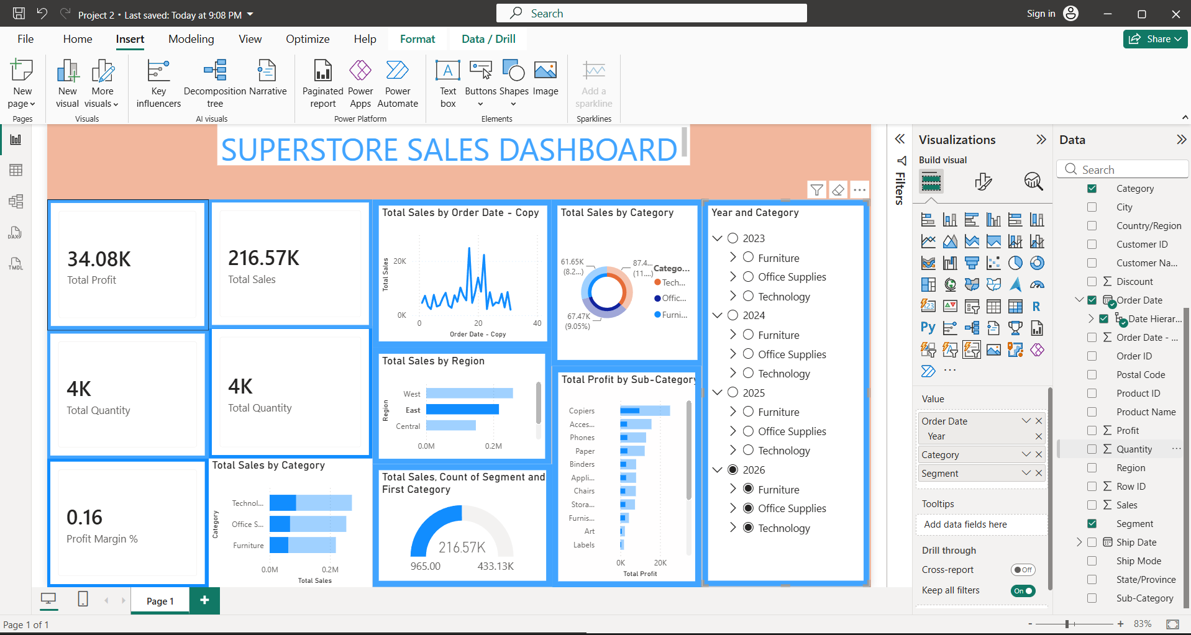
Figure 3 — Dashboard filtered to a narrower selection, isolating a smaller slice of years and categories.
A further, narrower selection isolates an even smaller slice of the data — Total Sales falls to 216.57K and Total Profit to 34.08K, while Profit Margin rises to 16%, the highest of the three views shown. This kind of comparison is exactly what the dashboard is designed for: a manager can toggle between the full dataset and specific year/category combinations to see not just how much was sold, but how profitable each slice actually was, since margin does not move in lockstep with revenue.

9. Key Insights from the Dashboard
- Technology consistently leads or closely competes for the top revenue-generating category across every filter combination tested, making it the most important category to monitor for forecasting.
- Profit margin is not stable across time slices — it ranged from roughly 13% at the full-data and 2024 views to 16% in a narrower selection — showing that revenue growth and profitability improvement do not always move together.
- Copiers and Phones are disproportionately strong profit contributors relative to their likely share of unit volume, suggesting they merit closer inventory and pricing attention than lower-margin sub-categories further down the ranked list.
- Regional performance is not static: East and West regions swap leading positions depending on the year selected, which argues against making blanket regional investment decisions from a single all-time view.
- The order-date trend line shows volatility rather than a clear long-term trend, reinforcing the value of the year/category slicer for spotting real shifts instead of reacting to short-term noise.

10. Challenges & Learnings
- Deciding measure logic: choosing DISTINCTCOUNT on Order ID for Total Orders (rather than counting rows) required understanding the difference between the fact table's line-item grain and the business's order-level grain.
- Avoiding divide-by-zero errors: early versions of Profit Margin % broke on filtered selections with zero sales until the calculation was rewritten using DIVIDE() instead of a raw division operator.
- Layout density: with seven visuals plus a slicer panel on one page, spacing and card sizing needed several iterations so that labels (particularly the long sub-category list) remained legible without a scroll on smaller screens.
- Filter propagation: confirming that the Year and Category tree filtered every visual — not just the ones added most recently — meant re-checking each visual's field wells and the model relationships rather than assuming Power BI's defaults were correct.

11. Conclusion
Week 2 converted the cleaned Superstore dataset from Week 1 into a working analytical asset. Establishing a Star Schema-aligned model, writing a compact set of well-defined DAX measures in a dedicated _Measures table, and laying those measures out across KPI cards, bar charts, a line chart, a donut chart, and a gauge produced a single-page dashboard that answers the original management problem statement: it lets a non-technical stakeholder monitor sales, profit, orders, and customer activity, and reslice that view by year, category, segment, and region in real time.
The three dashboard states captured in this report — the full unfiltered view, the 2024-only view, and a further narrowed selection — demonstrate that the interactivity objective was met: every card and chart responded consistently to slicer changes, and the underlying measures held up correctly even at small, filtered sample sizes. The resulting dashboard is ready to serve as the foundation for further work, such as adding a dedicated customer-analysis page or extending the model with additional dimension tables as the Superstore dataset grows.
Overall, this stage of the project reinforced a core BI principle: a dashboard is only as reliable as the data model and measures beneath it. Time invested in the Star Schema relationships and in writing robust, DIVIDE()-safe DAX paid off directly in a dashboard that behaves predictably under every filter combination tested.

